**Equipment and Disposable Products Agreement**

This Equipment and Disposable Products Agreement (the “Agreement”) is made between Philips Image Guided Therapy Corporation (FKA Volcano Corporation), Spectranetics LLC (FKA The Spectranetics Corporation) and Intact Vascular, Inc. (individually or collectively referred to herein as "Philips") and CUSTOMERNAME with a principal place of business at CUSTOMERADDRESS (“Customer”). Philips agrees to provide the Equipment and Disposable Products to Customer for use in its health care facility(ies) as specified in this Agreement, which includes the following and are inclusive of any sub-exhibits:

1. Equipment and Disposable Products “Terms and Conditions”
2. Contact Information
   1. Ordering, Return, Payment, Complaint Handling
3. Disposable Product Price Lists, are attached as Exhibits A;

Equipment purchase price identified on Exhibit A;

1. Customer facility(ies) listed on Exhibit B;
2. Equipment Specifications attached as Exhibits C;
3. Volume Based or Monthly Equipment Rental Pricing Programs, attached as Exhibits D;
4. Equipment-specific Terms and Conditions, attached as Exhibits E;
5. Consignment Addendum for Disposable Products specifically identified in Exhibit F;
6. Program Addendum, attached as Exhibit G.

**Term**: The Initial Term of this Agreement shall be from the Effective Date (defined below) to ENDDATE [Drafting Note: Eval Start Date+60 days+24 months (last day of 24th month)]. Thereafter, unless terminated sooner, this Agreement shall remain until the last end date specified in any of the attached Exhibits. End dates that are different than the end date specified in this paragraph shall be specifically set forth in each applicable Exhibit.

**Disposable Products**: Customer will purchase Disposable Products as shown on Exhibit(s) A (the “Disposable Products”). Upon written notice to Customer, Philips may add commercially available Disposable Products at Philips’ then-current price(s) to Exhibits A, as applicable.

**Price**: The Prices for the Disposable Products are set forth in Exhibits A, inclusive of any sub-exhibits, and shall remain firm for the Initial Term. Philips may adjust pricing during any Renewal Term upon 30-days’ written notice to Customer.

**Equipment**: Equipment as referenced in this Agreement, and the corresponding Exhibits, shall refer to either the Philips Laser System or the Philips Intravascular Imaging System. At Philips’ discretion and in consideration of current Equipment inventory levels, Customer agrees to receive either new or certified Equipment for use.

**Contact Information**: Should you have any questions, please contact your Philips Sales Representative, [Sales Rep Name], at XXX-XXX-XXXX or via email at @Philips.com.

**Acceptance**: This Agreement will be in effect as of the last date of authorized signature below (“Effective Date”), provided that a copy of this signed Agreement is received by Philips via email at [IGTD.SalesContracts@Philips.com](mailto:IGTD.SalesContracts@Philips.com) or via fax to 719-447-2022. Until such time as this Agreement becomes effective, this document will constitute a price quotation, which will remain valid for thirty (30) days from DATEOFCREATION.

[signature page follows]

***Signature page to Equipment and Disposable Products Agreement***

|  |  |
| --- | --- |
| **CUSTOMER:**  CustomerName  Authorized Signature  Printed Name  Title  Date: | **PHILIPS:**  Philips Image Guided Therapy Corporation  Spectranetics LLC  Intact Vascular, Inc.  Authorized Signature  Printed Name  Title  Date : |

**Equipment and Disposable Products Terms and Conditions**

1. **General**. This Agreement applies to all quotations made by or on behalf of Philips for all Equipment and Disposable Products. Customer’s acceptance of such quotations is limited to these Terms and Conditions, including all Exhibits attached hereto. This Agreement may be modified or amended only by a written instrument signed by duly authorized representatives of both parties, and additional or different terms or conditions in any communication by Customer (whether in a purchase order or otherwise) are hereby rejected and are null and void, irrespective of the means of acceptance. Philips’ failure to object to any additional or different provisions proposed by Customer does not constitute a waiver of these Terms and Conditions, nor constitute acceptance of any such Customer terms and conditions. This Agreement is the final, complete and exclusive Agreement of the parties with respect to the subject matter hereof and supersedes and merges all prior discussions.

<<doc [Clause.ClauseId] -build>>

**3. Purchase Order and Payment Terms**.

<<doc [DAR.ClauseId] -build>>

**3.2 Equipment:** Customer must issue a purchase order for the purchase or rental of the Equipment prior to shipment of the Equipment. Invoices will be issued in accordance with the applicable rental or purchase terms contained in the applicable Exhibit(s) attached hereto.

**4. Shipment, Title, Risk of Loss**.

**4.1 Disposable Products.** Shipping charges will be prepaid by Philips and invoiced. Disposable Product sales are made F.O.B. Philips’ manufacturing facility, and title and risk of loss passes to Customer at the time of Philips’ delivery to the carrier. Disposable Products provided on a consignment basis in accordance with the Consignment Exhibit are shipped F.O.B. destination and risk of loss, but not title, passes to Customer at the time of delivery to Customer. Customer grants Philips a security interest in the Disposable Products for the unpaid balance of the purchase price.

**4.2 Equipment**: Shipment of Equipment is FOB origin, unless otherwise specified in the respective Equipment Exhibits. For applicable Equipment, Philips will provide the services of a certified field service engineer (“Certified Field Service Engineer”) to perform customary testing procedures promptly following delivery. Philips will provide Customer with written certification that the Equipment is performing in accordance the Equipment’s written specifications following satisfactory completion of the field testing (the “Field Certification”). Title to purchased Equipment shall pass to Customer at the time of delivery to Customer. In the instance of rented Equipment, Philips will retain legal title to the Equipment at all times. Notwithstanding Philips’ holding legal title, Customer will list Philips as the loss payee in Customer’s insurance that insures the Equipment against damage, vandalism, and theft and will provide evidence of this insurance to Philips. Philips may, at its discretion, file a UCC financing statement, for informational purposes, in connection with rented Equipment placed with Customer under this Agreement.

**5. Limited Warranty.**

**<<doc [Disposable.ClauseId] -build>>**

**<<doc [Equipment.ClauseId] -build>>**

**6. Returns.**

**<<doc [Returns.ClauseId] -build>>**

<<doc [Returns2.ClauseId] -build>>

<<doc [Returns3.ClauseId] -build>>

<<doc [Returns4.ClauseId] -build>>

<<doc [Returns5.ClauseId] -build>>

**7. Equipment Maintenance and Support Services.** Philips will provide Customer with the Equipment maintenance and support services provided in each respective Equip ment Exhibit.

<<doc [Notices.ClauseId] -build>>

**9. Force Majeure.** Each party shall be excused from performing its obligations (except for payment obligations) arising from any delay or default caused by events beyond its reasonable control including, but not limited to, acts of God, acts of any civil or military authority, fire, floods, war, embargoes, labor disputes, acts of sabotage, riots, accidents, terrorism, national emergency, strikes, subcontractors or suppliers, pandemics, epidemics, viral outbreaks, or by any other cause not within the control of the party whose performance is interfered with which, by the exercise of reasonable diligence, such party is unable to prevent, whether of the class or causes enumerated above or not. For the sake of clarity, any supply chain disruption due to COVID-19 shall be considered a force majeure event.

**10. Assignment**. Customer may not assign any rights or obligations in connection with the transactions contemplated by this Agreement without the prior written consent of Philips, which consent shall not be unreasonably withheld, and any attempted assignment without such consent shall be of no force or effect. Notwithstanding the foregoing, either party may assign its interest in this Agreement to any entity directly or indirectly controlled by the assigning party, or to any successor by merger or sale of substantially all of its assets. The provisions of this Agreement will inure to the benefit of the permitted assigns and successors in interest of the assigning party. Customer acknowledges and agrees that Philips may appoint its affiliates to perform some or all of its functions or obligations under this Agreement, provided however, that Philips shall remain responsible for performance by its affiliates.

**11. Compliance with Law.** Each party shall comply with all laws, rules, and regulations applicable to the party in connection with the performance of its obligations in connection with this Agreement, including, but not limited to, those relating to affirmative action, fair employment practices, FDA, Medicare fraud and abuse, and the Health Insurance Portability and Accountability Act of 1996 ("HIPAA"). Health care providers are reminded that if the purchase includes a discount or loan, they must fully and accurately report such discount or loan on cost reports or other applicable claims for payment submitted under any federal or state health care program, including but not limited to Medicare and Medicaid, as required by federal law. Each party represents and warrants to the other party that it is not excluded from participation in any Federal Health Care Program or debarred, suspended, or otherwise excluded from participating in any other federal procurement program or activity. In the event of a party’s breach of this Section 11, the non-breaching party may terminate this Agreement immediately without further penalty or liability.

**12. Discounts**. The parties acknowledge that the prices under this Agreement may reflect discounts, rebates, or other reductions in price (collectively, “discounts”), and it is their intention that such discounts shall be administered consistent with the discount exception to the federal anti-kickback statute (42 USC 1320a-7b(B)(3)(A)) and the related regulatory discount safe harbor (42 CFR 1001.952(h)). Philips will reflect when a discount applies on invoices or alternative documents, and Customer may request additional documentation of purchases and discounts hereunder as necessary to facilitate appropriate reporting. To the extent and as required by applicable law, regulations, or other contractual obligations, it is Customer’s responsibility to appropriately report or reflect such discounts, including any bundled discounts, on cost reports or claims submitted to third party payors, including but not limited to federal or state health care programs. Further, Customer will retain documentation provided by Philips relating to purchases and discounts hereunder and make it available to federal or state health care program representatives upon request.

**13.Governing Law**. All transactions contemplated by this Agreement shall be governed by the laws of the state where the Customer is located, without regard to that state’s choice of law principles, without regard to provisions on the conflicts of laws or to the UN Convention of Contracts for the International Sale of Goods and expressly excluding application of the Uniform Computer Information Transactions Act (“UCITA”), in any form. EACH PARTY, KNOWINGLY AND AFTER CONSULTATION WITH COUNSEL, FOR ITSELF, IT’S SUCCESSORS’ AND ASSIGNS, WAIVES ALL RIGHT TO TRIAL BY JURY OF ANY CLAIM ARISING WITH RESPECT TO THIS AGREEMENT OR ANY MATTER RELATED IN ANY WAY THERETO.

<<doc [Confident.ClauseId] -build>>

<<doc [Idemnity.ClauseId] -build>>

**15.1** Philips will have no indemnity or defense obligation for any Claim that arises from: (i) the negligent act or omission, or willful misconduct of Customer; (ii) Disposable Products that are or have been expired, repaired, altered, modified or reprocessed except by or under authorization from Philips; (iii) Disposable Products not used or stored in accordance with the instructions for use; (iv) Disposable Products that have been modified by Philips in accordance with Customer-provided specifications or instructions; or (v) third party products.

**15.2** Customer will indemnify and defend Philips against any third party Claim to the extent the Claim directly arises from Section 15.1 (i), (ii), (iii), (iv), or (v) above.

**15.3** The obligations of the indemnifying party are conditioned on the following: (a) indemnified party notifies indemnifying party of Claim in writing within thirty (30) days of the indemnified party being made aware of the Claim; (b) the indemnified party gives indemnifying party sole authority and control of the defense or settlement of the Claim with counsel of the indemnifying party’s choice; and (c) indemnified party provides all information and assistance requested by the indemnifying party to handle the defense or settlement of the Claim.

<<doc [Limitation.ClauseId] -build>>

**17. Disclaimer.** TO THE MAXIMUM EXTENT PERMITTED BY APPLICABLE LAW, IN NO EVENT SHALL PHILIPS, ITS AFFILIATES AND/OR ITS SUPPLIERS BE LIABLE FOR COSTS OF PROCUREMENT OF SUBSTITUTE PRODUCTS, EQUIPMENT OR SERVICES, LOST PROFITS, DATA OR BUSINESS, OR FOR ANY PUNITIVE, INDIRECT, SPECIAL, INCIDENTAL, UNFORESEEABLE, EXEMPLARY OR CONSEQUENTIAL DAMAGES OF ANY KIND ARISING OUT OF OR RELATED TO THIS AGREEMENT, INCLUDING LICENSED SOFTWARE, AND/OR SERVICE HOWEVER CAUSED AND ON ANY THEORY OF LIABILITY (WHETHER IN CONTRACT, TORT, NEGLIGENCE, STRICT LIABILITY OR OTHERWISE), EVEN IF PHILIPS HAS BEEN ADVISED OF THE POSSIBILITY OF SUCH LOSS.

1. **Termination**. Notwithstanding anything to the contrary under this Agreement, after the Initial Term, either party may terminate this Agreement for convenience upon thirty (30)-days’ written notice to the other party. Philips may also terminate this Agreement as follows: (i) upon Customer’s material breach of this Agreement, in which case, Philips shall notify Customer in writing, identifying the breach, and Customer will have fifteen (15) days following such notice to remedy the breach. If the Customer fails to remedy the breach during that period, Philips may by written notice terminate this Agreement; or (ii) immediately upon the appointment of a receiver for the Customer, assignment for the benefit of creditors by Customer, or commencement of any voluntary or involuntary proceedings under any bankruptcy or insolvency laws against the Customer. Upon termination, Philips shall have the right to cancel future deliveries of Disposable Products and/or Equipment and Customer shall provide Philips access to its facilities during normal business hours; Customer shall cooperate with Philips for the immediate removal of all rented Equipment.
2. **Equipment Log File Access**. Customer agrees that Philips may periodically remotely connect to Philips equipment and collect and use information from the system log file for Philips’ own business purposes (including, but not limited to, for data analytics activities, to facilitate and advise on continued and sustained use of Philips’ or its affiliates’ products and services, for research, product and service development and improvement (including the development of new offerings), substantiation of marketing claims and for benchmarking purposes). The system log file does not contain any protected health information (within the meaning of the HIPAA Privacy Rule) or any information that is capable of identifying an individual.
3. **Resale**. Customer represents and warrants that the Equipment and Disposable Products are being acquired solely for the Customer’s own use at the Customer facility(ies) listed on Exhibit B. Customer shall not resell the Equipment or Disposable Products.
4. **PHI Deletion**. If Equipment is rented under this Agreement, Customer agrees to delete all data collected on the Equipment (with Philips’ reasonable instructions) including specifically any and all data constituting Protected Health Information as that term is defined in 45 CFR 164.502(d) prior to returning the Equipment to Philips at the expiration of any rental term under this Agreement.
5. **Miscellaneous.** Customer shall report to Philips any problems with Philips’ products or use thereof of which Customer becomes aware. No failure or delay (in whole or in part) by either party to exercise any right or remedy hereunder operates as a waiver thereof or effect any other right or remedy. All rights and remedies hereunder are cumulative and are not exclusive of any other rights or remedies provided hereunder or by law. The waiver of one breach or default or any delay in exercising any rights does not constitute a waiver of any subsequent breach or default. Neither party hereto is deemed an agent of the other party. If any of these Terms and Conditions are held to be invalid under any statute or rule of law, they are, to that extent, deemed omitted and the remaining provisions shall continue in full force and effect. Philips owns and retains all patent rights, copyrights, trademarks, trade secrets and all other intellectual property rights in and to its Equipment or Disposable Products. Philips reserves all rights and no licenses are granted by Philips to Customer under this Agreement, whether by implication, estoppel or otherwise. Customer’s obligations are independent of any other obligations the Customer may have under any other agreement, contract, or account with Philips. Customer will not exercise any right of offset in connection with the terms and conditions in the quotation or in connection with any other agreement, contract, or account with Philips.

**Contact Information**

|  |  |  |
| --- | --- | --- |
|  | **Spectranetics LLC and Laser System** | **Philips Image Guided Therapy Corporation and Intravascular Imaging Equipment** |
| **Ordering and Returns\*** | Phone: 800-231-0978  Email: [OrderIGTDevices@Philips.com](mailto:OrderIGTDevices@Philips.com)  7:00 a.m. to 5:00 p.m. Mountain Standard Time | Phone: 800-228 4728  Email: [OrderIGTDevices@Philips.com](mailto:OrderIGTDevices@Philips.com)  Fax: 916-638-8812  6:00 a.m. to 5:00 p.m. Pacific Standard Time |
| **Equipment Support and Maintenance\*\*** | Phone: 800-231-0978 | Phone: 800-228-4728 |
| **Disposable Product Complaints** | Phone: 800-228-4728  Email: [IGTD.CustomerInquiry@Philips.com](mailto:IGTD.CustomerInquiry@Philips.com) | Phone: 800-228-4728  Email: [IGTD.CustomerInquiry@Philips.com](mailto:IGTD.CustomerInquiry@Philips.com) |
| **Equipment Complaints** | Phone: 800-231-0978  Email: [complaints@spnc.com](mailto:complaints@spnc.com) | Phone: 800-228-4728  Email: [IGTD.RemoteSupport@Philips.com](mailto:IGTD.RemoteSupport@Philips.com) |

**\***For Ordering and Returns, please reference Exhibits A to determine appropriate product reference.

**\*\***Maintenance will be scheduled between 8:00 am and 5:00 pm at Customer’s facility, Monday through Friday, excluding holidays.

**Exhibit A-1**

**Disposable Products Price List**

**Spectranetics LLC Products**

**[INSERT PRICE LIST(S)]**

**Exhibit A-2**

**Disposable Products Price List**

**Philips Image Guided Therapy Corporation Products**

**[INSERT PRICE LIST(S)]**

**Exhibit B**

**Customer Facility(ies)**

**Delivery Location(s):** Disposable Products and Equipment are to be delivered to the following location(s):

|  |
| --- |
| INSERT CUSTOMER  ADDRESS  CITY, ST ZIP |
|
|
|

|  |  |
| --- | --- |
| **FOR PHILIPS USE ONLY** | |
| Philips MP1: |  |
| SPNC: |  |
| IGTD #: |  |

**Exhibit C-1**

**Equipment Specifications**

**Laser System Equipment**

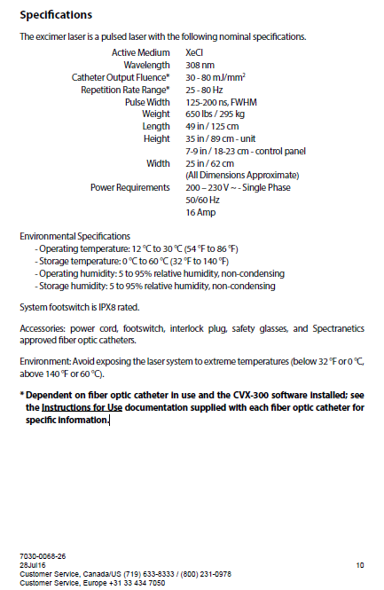

**Exhibit C-2**

**Equipment Specifications**

**Intravascular Imaging Equipment**





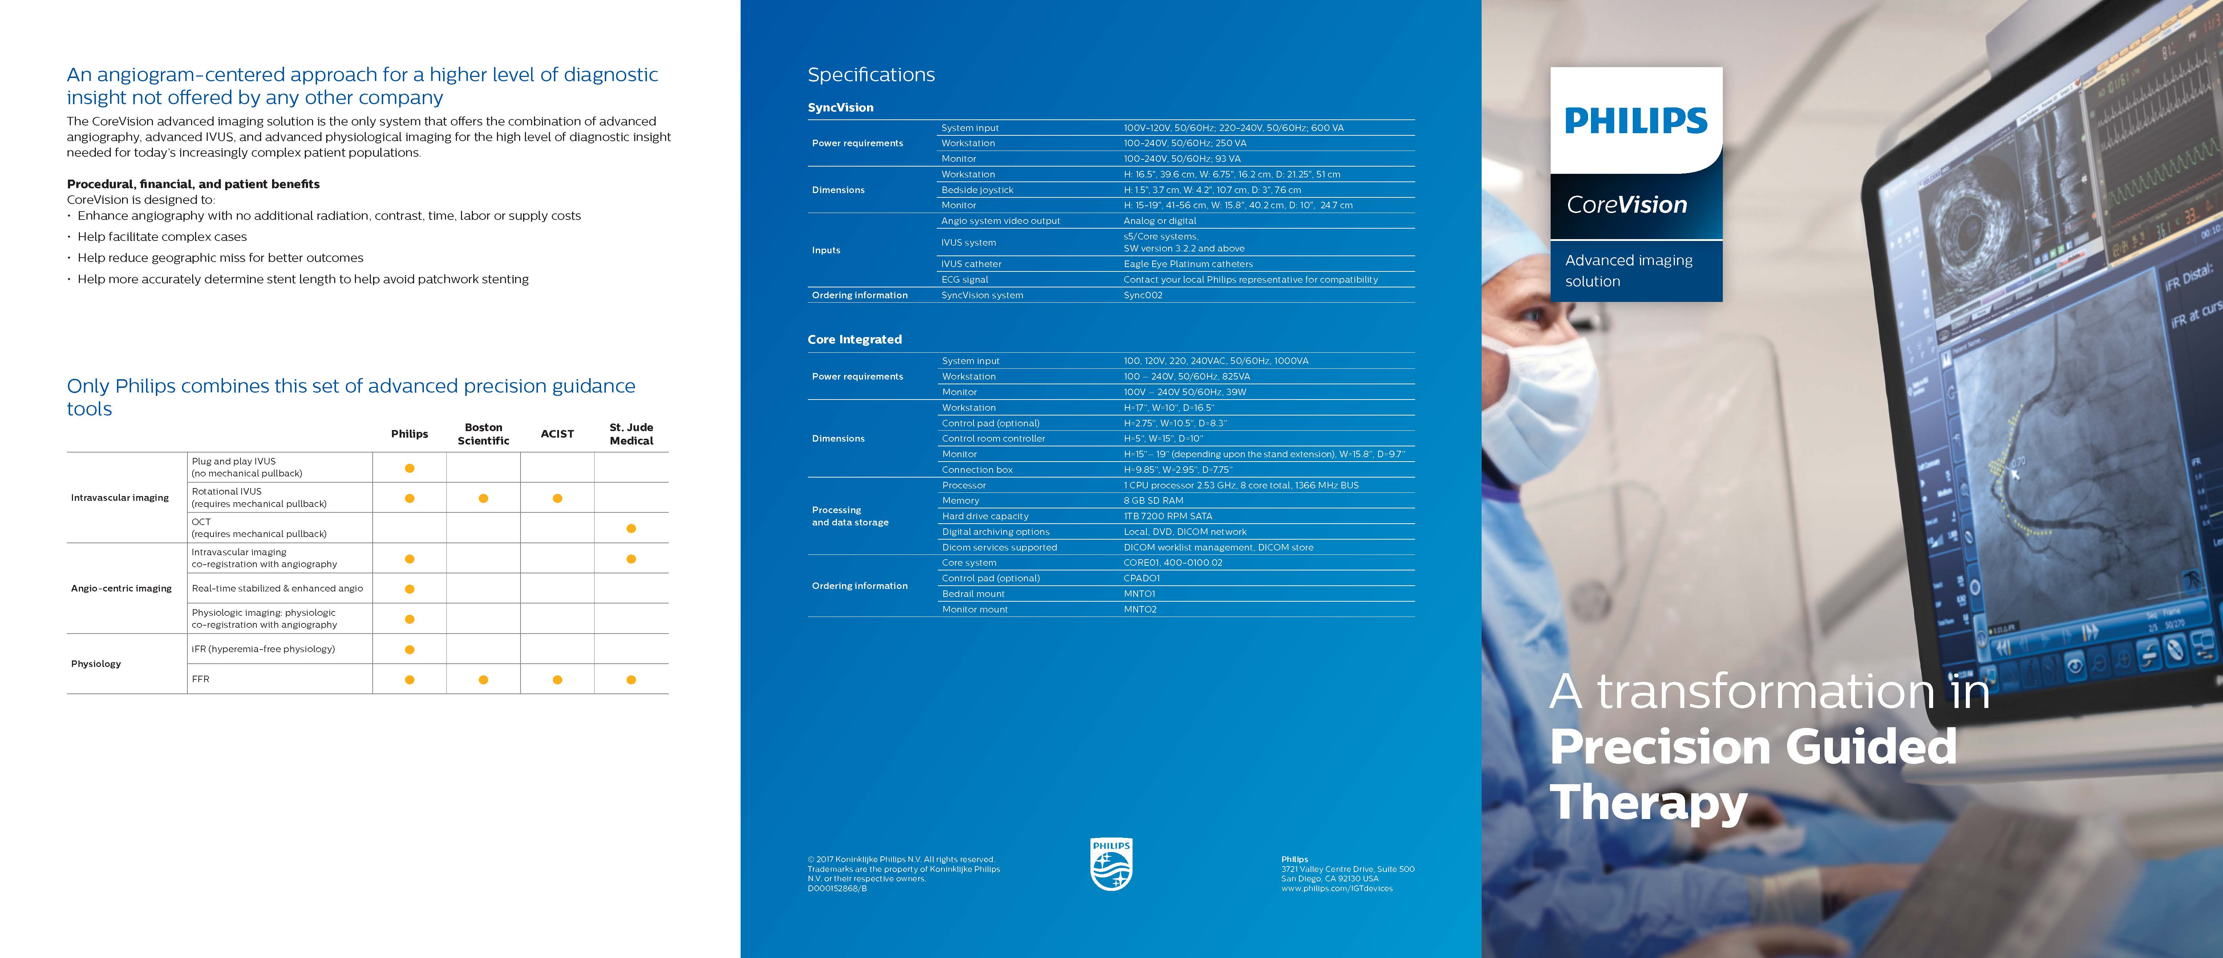

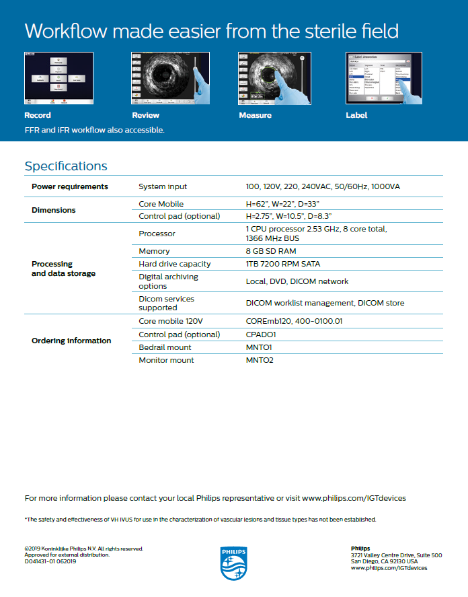

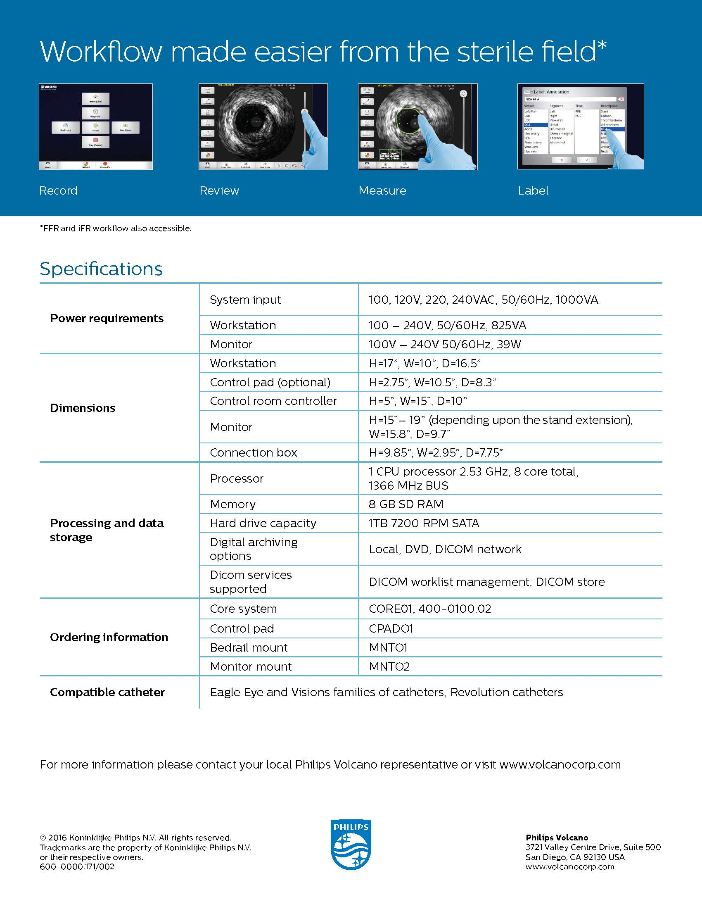

**Equipment Specifications**

**IntraSight**

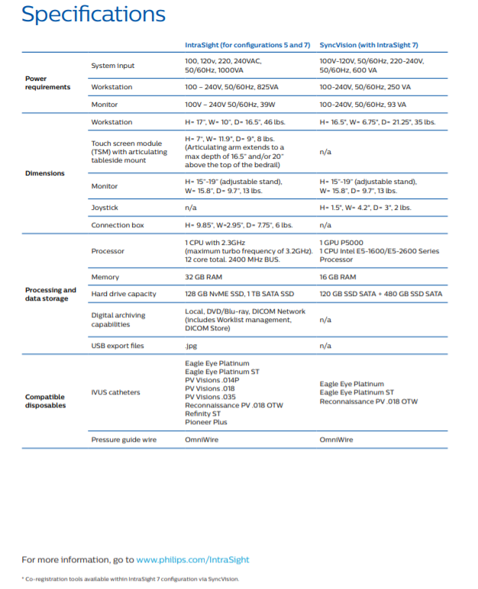

**Exhibit D-1**

**Volume Based OR Flat Rental Laser Rental Pricing Program**

**Laser System:** For purposes of this Rental Pricing Program, the system shall be a CVX-300 Excimer Laser System.

**Evaluation Period:** Upon new Laser System(s) installation, Customer shall have sixty (60) days in which to evaluate the Laser System(s) (the “Evaluation Period”). Customer will not be responsible for any new Laser System(s) fees during the Evaluation Period. An Evaluation Period is only available for newly placed Laser System(s).

**Rental Term:** The initial Rental Term will begin immediately following [the Evaluation Period / installation] and will end on ENDDATE (Drafting note: 24 months from installation date) (the “**Initial Rental Term**”) unless otherwise terminated during the Evaluation Period. [The parties may agree to renew the Agreement in a writing signed by both parties for additional twelve (12) month periods, each a “**Renewal Term.**”] [ After the Initial Rental Term, this Laser Rental Pricing Program shall autorenew for additional one year periods, each a “**Renewal Term**”, unless either party provides notice to the other party of its intention not to renew the program at least thirty days prior to the expiration of the then current Rental Term (as defined herein).] The Initial Rental Term, together with any Renewal Terms are collectively referred to herein as the “Rental Term.”

**Rental Fee:** The rental fee for the Laser System(s) is $10,500 per Laser System, per [calendar quarter / the end of each twelve (12) month period] of the Rental Term (the “Rental Fee”). The Rental Fee will be prorated for any partial period based on the commencement of the Rental Term. The Rental Fee will be invoiced in accordance with the Rental Pricing Program contained herein.

**Program:** Rental Credit Program is based on the Rental Fee and the program will be measured based on the scale below. Customer must place a stocking order for a minimum amount of $24,000 of Disposable Products prior to shipment of the Equipment.

**Calculation and Application of Rent Credits:** Total rent credit will be calculated on the Rental Fee, based on net purchase dollar volume of all Disposable Products within the Eligible Product groups listed in this Exhibit below. Rent credits vest as each Purchase Volume Tier is achieved. Rent credits will accrue only on the first $150,000 of Eligible Disposable Products purchased during each twelve (12) month period during the Rental Term, which shall be prorated for any partial Rental Term.

For purposes of earning rent credits, “purchases” of Disposable Products will be considered to be made, and will be counted when the Customer issues a purchase order for such Disposable Products.

If applicable, Philips will invoice the Rental Fee no later than thirty (30)-days after the end of each [calendar quarter / twelve (12) month period]. Any excess credits at the end of the Initial Rental Term will carry over into the next Renewal Term, but will not be carried over into any subsequent Renewal Term.

[delete this paragraph for ANNUAL VBs] Any excess credits at the end of the initial twelve (12) month period of the Initial Rental Term will carry over into the next quarter. No further credit carryover is permitted.

Once the Customer achieves $150,000 volume of Eligible Disposable Products purchased, net of returns, in a Renewal Term, the Rental Credit Program will be deemed complete and no further credits will be earned until the next Renewal Term.

[delete this paragraph for ANNUAL VBs] At the end of each calendar quarter, Philips will review the prior twelve (12) month period under the terms of this Agreement and if the total volume meets or exceeds $150,000 annual purchase volume then any rent paid, pursuant to a quarterly rental invoice, by the Customer, will be credited back to the Customer in a form of a credit to their account.

If applicable, purchases made during any Evaluation Period and the initial stocking order placed at the time this contract is executed, shall be added to purchases made during the initial twelve (12) month period, for purposes of determining the Rental Term Purchase Volume.

**Rental Credit Program Scale**

**[INSERT VOLUME TABLE]**

**Volume Based Eligible Disposable Products:**

Laser Atherectomy Catheters (e.g., Turbo-Elite, Turbo-Power, ELCA)

Aspiration Catheters (e.g., QuickCat)

Lead Extraction Mechanical Catheters (e.g., TightRail, SightRail, LLD)

Lead Extraction Laser Catheters (e.g., GlideLight, SLS II)

Lead Management Accessories (e.g., TorqMax)

Crossing Solutions (e.g., Quick-Cross, Quick-Cross Extreme, Quick-Cross Select)  
Access Solutions (e.g., Quick-Access)

AngioSculpt™ PTA and PTCA

Stellarex Drug Coated Angioplasty Balloons

**Note:** Any rent credits earned pursuant to this program constitute reductions in the price of the products to which they are applied, and the purchase price of all products net of rent credits and any other discount or rebate must be fully reported as may be required by applicable healthcare laws and regulations, including on Medicare and/or Medicaid cost reports.

Customer is responsible for any damage to Equipment due to negligence, willful misconduct, or misuse of the Equipment (including use of Equipment with disposable products, including reprocessed disposables, which are not recommended by Philips to be used with the Equipment) by Customer, its personnel or its agents.  Customer agrees to pay for all service charges, including travel, parts and labor to repair or replace any such damaged Equipment.

**System Price:** The list price for the Laser System is $349,000.

**DELETE this exhibit if VB**

**if selecting Flat rent, DELETE VB exhibit above**

**Exhibit D**

**Monthly Rental Pricing Program**

**Evaluation Period:** Upon new Laser System(s) installation, Customer shall have sixty (60) days in which to evaluate the Laser System(s) (the “Evaluation Period”). Customer will not be responsible for any new Laser System(s) fees during the Evaluation Period. An Evaluation Period is only available for newly placed Laser System(s).

**Rental Term:**  The initial Rental Term will begin immediately following the expiration of the Evaluation Period and will end on ENDDATE (Drafting note: same as ENDDATE date on page 1) (the “Initial Rental Term”) unless otherwise terminated during the Evaluation Period. The Rental Term will automatically renew for additional one year periods, each a “Renewal Term” unless one party provides the other party with written notice of non-renewal at least thirty (30) days prior to the expiration of the then current Term. The Initial Rental Term, together with any Renewal Terms are collectively referred to herein as the “Rental Term.”

**Rental Fee:**  The rental fee for the Laser System(s) is $10,500 per Laser System, per month (the “Rental Fee”). The Rental Fee will be prorated for any partial period based on the commencement of the Rental Term. The Rental Fee will be invoiced monthly.

**Exhibit D-2**

**Volume Based Intravascular Imaging System Rental Pricing Program**

**Intravascular Imaging System:** For purposes of this Rental Pricing Program, the System shall be the [INSERT SYSTEM].

**Evaluation Period:** Upon new System(s) installation, Customer shall have sixty (60) days in which to evaluate the System(s) (the “**Evaluation Period**”). Customer will not be responsible for any System(s) fees during the Evaluation Period. An Evaluation Period is only available for newly placed System(s).

**Rental Term:** The initial Rental Term will begin [upon the Effective Date] immediately following the installation and will end on ENDDATE (Drafting note: 24 months from installation date) (the “**Initial Rental Term**”) unless otherwise terminated during the Evaluation Period. [The parties may agree to renew the Agreement in a writing signed by both parties for additional twelve(12) month periods, each a “**Renewal Term.**”] [ After the Initial Rental Term, this Volume Based Intravascular Imaging System Rental Pricing Program shall autorenew for additional one year periods, each a “**Renewal Term**”, unless either party provides notice to the other party of its intention not to renew the program at least thirty days prior to the expiration of the then current Rental Term (as defined herein).] The Initial Rental Term, together with any Renewal Terms are collectively referred to herein as the “Rental Term.”

**Rental Fee:** The rental fee for the System(s) is $10,500 per System, per [calendar quarter / twelve (12) month period] of the Rental Term (the “Rental Fee”). The Rental Fee will be prorated for any partial period based on the commencement of the Rental Term. The Rental Fee will be invoiced in accordance with the Rental Pricing Program contained herein.

**Program:** Rental Credit Program is based on the Rental Fee and the program will be measured based on the scale below. Customer must place a stocking order for a minimum amount of $8,000 of Disposable Products prior to shipment of the Equipment.

**Calculation and Application of Rent Credits:** Total rent credit will be calculated on the Rental Fee, based on net purchase dollar volume of all Disposable Products within the Eligible Product groups listed in this Exhibit below. Rent credits vest as each Purchase Volume Tier is achieved. Rent credits will accrue only on the first $55,000 of Eligible Disposable Products purchased during each twelve (12) month period during the Rental Term, which shall be prorated for any partial Rental Term.

For purposes of earning rent credits, “purchases” of Disposable Products will be considered to be made, and will be counted when the Customer issues a purchase order for such Disposable Products.

If applicable, Philips will invoice the Rental Fee no later than thirty (30)-days after the end of each [calendar quarter / twelve (12) month period]. Any excess credits at the end of the Initial Rental Term will carry over into the next Renewal Term, but will not be carried over into any subsequent Renewal Term.

[delete this paragraph for ANNUAL VBs] Any excess credits at the end of the initial twelve (12) month period of the Initial Rental Term will carry over into the next quarter. No further credit carryover is permitted.

Once the Customer achieves $55,000 volume of Eligible Disposable Products purchased, net of returns, in a Renewal Term, the Rental Credit Program will be deemed complete and no further credits will be earned until the next Renewal Term.

[delete this paragraph for ANNUAL VBs] At the end of each calendar quarter, Philips will review the prior twelve (12) month period under the terms of this Agreement and if the total volume meets or exceeds $55,000 annual purchase volume then any rent paid, pursuant to a quarterly rental invoice, by the Customer, will be credited back to the Customer in a form of a credit to their account.

Purchases made during any Evaluation Period and the initial stocking order placed at the time this contract is executed, shall be added to purchases made during the initial twelve (12) month period, for purposes of determining the Rental Term Purchase Volume.

**Rental Credit Program Scale**

**[INSERT VOLUME TABLE]**

**Volume Based Eligible Disposable Products:**

Refinity Rotational IVUS Catheters

VERRATA Plus Coronary Pressure Guidewire

OmniWire Coronary Pressure Guidewire

Eagle Eye Platinum Coronary Imaging Catheter

Eagle Eye Platinum ST Coronary Imaging Catheter

Visions Digital IVUS Peripheral Catheter

**Note:** Any rent credits earned pursuant to this program constitute reductions in the price of the products to which they are applied, and the purchase price of all products net of rent credits and any other discount or rebate must be fully reported as may be required by applicable healthcare laws and regulations, including on Medicare and/or Medicaid cost reports.

Customer is responsible for any damage to Equipment due to negligence, willful misconduct, or misuse of the Equipment (including use of Equipment with disposable products, including reprocessed disposables, which are not recommended by Philips to be used with the Equipment) by Customer, its personnel or its agents.  Customer agrees to pay for all service charges, including travel, parts and labor to repair or replace any such damaged Equipment.

**System Price:** The list price for the Vascular Imaging System is $XXX,XXX.

**DELETE this exhibit if VB**

**if selecting Flat rent, DELETE VB exhibit above**

**EXHIBIT D**

**Monthly Rental Pricing Program**

**Evaluation Period:** Upon new Intravascular Imaging System(s) installation, Customer shall have sixty (60) days in which to evaluate the Intravascular Imaging System(s) (the “Evaluation Period”). Customer will not be responsible for any fees during the Evaluation Period. An Evaluation Period is only available for newly placed Intravascular Imaging System(s).

**Rental Term:** The initial Rental Term will begin immediately following the expiration of the Evaluation Period and will end on ENDDATE (Drafting note: 24 months from installation date) (the “**Initial Rental Term**”) unless otherwise terminated during the Evaluation Period. The parties may agree to renew the Agreement in a writing signed by both parties for additional one year periods, each a “**Renewal Term**.” The Initial Rental Term, together with any Renewal Terms are collectively referred to herein as the “Rental Term.”

**Rental Fee:**  The rental fee for the Intravascular Imaging System(s) is $5,000 per System, per month (the “Rental Fee”). The Rental Fee will be prorated for any partial period based on the commencement of the Rental Term. The Rental Fee will be invoiced monthly.

**Exhibit E-1**

**Additional Terms and Conditions**

**Laser System**

1. **Laser System(s) Returns:** In the case of a return of a defective Laser System(s) for warranty service or replacement, such shipment may be freight collect.
2. **Limited Warranty:** Philips warrants that the Laser System(s) will meet the Specifications and the provisions of the Operator’s Manual supplied by Philips (the “Operator’s Manual”) commencing on the date on which Philips issues a Field Certification and continuing as applicable until: (x) the end of the Rental Term; or (y) one (1) year for purchased Laser System(s) (the “Warranty Period”). This Limited Warranty is subject to the following conditions: (i) the Laser System(s) must be installed and field certified by a Certified Field Service Engineer; (ii) the Laser System(s) must be operated and stored in accordance with the Specifications and the Operator's Manual; (iii) all required and recommended maintenance, upgrades, and modifications must be performed by Certified Field Service Engineers using authorized parts, components, and gases; and (iv) the Laser System(s) must be operated by trained personnel according to approved clinical guidelines using authorized disposable devices.

Philips’ sole obligation under this Laser System(s) Warranty shall be to provide parts and labor required to cause the Laser System(s) to operate in accordance with the specifications during the Warranty Period. Philips, in its sole discretion, reserves the right to use new or like new parts in servicing or repair of the Laser System(s).

1. **Maintenance and Support Services.** Philips will provide Customer with unlimited technical telephone support during business hours in the Mountain Time zone by calling (800) 231-0978. Customer will permit Philips to provide maintenance and repair including upgrades and modification to the Laser System(s) as required.

Philips will perform all service and repairs during the normal business hours of 8:00 am to 5:00 pm at Customer’s facility, Monday through Friday, excluding holidays. Customer is responsible for assuring that the Laser System(s) is accessible to Certified Field Service Engineers at the scheduled time. Customer will pay Philips at its standard billing rates for: (i) repairs requested outside of normal business hours; waiting time if the Laser System(s) is not available for scheduled maintenance; (ii) service made necessary as a result of Customer’s failure to follow the requirements in the Operator’s Manual; or (iii) service that is required due to any damage to the Laser System(s) from outside causes.

**[DELETE FOR OBL VBA – USE FOR CAPITAL EQUIPMENT PURCHASE & HOSPITAL VBA]**

**Exhibit E-1**

**Additional Terms and Conditions**

**Intravascular Imaging System**

1. **Limited Warranty.** Philips warrants that the System(s) will meet the Specifications and the provisions of the Operator’s Manual supplied by Philips (the “Operator’s Manual”) commencing on the date on which the System(s) is/are installed for one (1) year (the “Warranty Period”). This Limited Warranty is subject to the following conditions: (i) the System(s) must be correctly installed; (ii) the System(s) must be operated and stored in accordance with the Specifications and the Operator's Manual; and (iii) the System(s) must be operated by trained personnel according to approved clinical guidelines.

Philips’ sole obligation under this Limited Warranty shall be to provide parts and labor required to cause the System(s) to operate in accordance with the specifications during the Warranty Period. Philips, in its sole discretion, reserves the right to use new or like new parts in servicing or repair of the System(s).

1. **Service Agreement Options.**  By written agreement of the parties, Customer agrees to purchase maintenance and service coverage for each placed System at any time during the Term of this Agreement by contacting [igtdservicecontracts@philips.com](mailto:igtdservicecontracts@philips.com). For informational purposes, the current Service Agreement pricing is provided below. Point of Sale Discount Prices set forth on the table below is only offered at the time this Agreement is executed, and must be selected by Customer as the maintenance and service coverage option when the Customer issues a purchase order for the System in connection with this Agreement. Philips will invoice 30-days prior to expiration of the Warranty.
2. **Philips Remote Service (“PRS”).** If requested by Philips, Customer will provide Philips with outbound internet access over SSL; at all times during the warranty period provide full and free access to the equipment and the Customer network for Philips’ use in remote servicing of the product, remote assistance to personnel that operate the products, updating the products software, transmitting automated status notifications from the product and regular uploading of products data files (such as but not limited to error logs and utilization data for improvement of Philips products and services and aggregation into services). Customer’s failure to provide such access will constitute Customer’s waiver of the maintenance service and will void support or warranty coverage of product malfunctions until PRS access is provided.
3. **End User License Agreement (“EULA”).** Customer agrees that use of software embedded in capital products is subject to the terms of the End User License Agreement, as it may be updated by Philips from time to time (“EULA”). A copy of the EULA is also available online at [https://www.usa.philips.com/c-dam/b2bhc/us/terms-conditions/volcano-software-end-user-license-agreement.pdf](https://eur01.safelinks.protection.outlook.com/?url=https%3A%2F%2Fwww.usa.philips.com%2Fc-dam%2Fb2bhc%2Fus%2Fterms-conditions%2Fvolcano-software-end-user-license-agreement.pdf&data=02%7C01%7C%7C181461f2a3a6448d499c08d871291732%7C1a407a2d76754d178692b3ac285306e4%7C0%7C0%7C637383768875403781&sdata=Jr53koGNJ%2BM0VqNYOnb1qvElpuz0tBfsENcrCKsP1dA%3D&reserved=0). The terms of the EULA are incorporated herein by reference.

|  |  |  |  |  |  |  |  |
| --- | --- | --- | --- | --- | --- | --- | --- |
| **Service Agreement** | **CORE** | **CORE Mobile** | **COREVision** | **Core M2** | **Certified**  **CORE Mobile** | **s5 Imaging System** | **SyncVision** |
| List Price Per Unit/Per Year: | $14,600.00 | $17,000.00 | $24,600.00 | $18,500.00 | $17,000.00 | $17,000.00 | $10,000.00 |
| Point of Sale Discount Price for 1 Year/Per Unit | $9,800.00 | $11,700.00 | $17,000.00 | $11,700.00 | $11,700.00 | $11,700.00 | $8,000.00 |
| Point of Sale Discount Price for 2 Years/Per Unit | $18,000.00 | $22,000.00 | $30,600.00 | $21,200.00 | $21,200.00 | $21,200.00 | $14,560.00 |
| Point of Sale Discount Price for 3 Years/Per Unit | $24,900.00 | $30,000.00 | $41,250.00 | $29,400.00 | $29,400.00 | $29,400.00 | $19,440.00 |

*\*Point of Sale Discount Price: Purchase order must be received upon execution of this Agreement.*

**[USE FOR OBL VBA ONLY]**

**Exhibit E-1**

**Additional Terms and Conditions**

**Intravascular Imaging System**

1. **Limited Warranty.** Philips warrants that the System will meet the Specifications and the provisions of the Operator’s Manual supplied by Philips (the “Operator’s Manual”) commencing on the date on which the System is/are installed for one (1) year (the “Warranty Period”). This Limited Warranty is subject to the following conditions: (i) the System must be correctly installed; (ii) the System must be operated and stored in accordance with the Specifications and the Operator's Manual; and (iii) the System must be operated by trained personnel according to approved clinical guidelines.

Philips’ sole obligation under this Limited Warranty shall be to provide parts and labor required to cause the System to operate in accordance with the specifications during the Warranty Period. Philips, in its sole discretion, reserves the right to use new or like new parts in servicing or repair of the System.

1. **Warranty.** The System includes a One (1) year basic protection warranty from the original installation date and is incorporated herein by reference (the “Limited Warranty”). Upon expiration of the Limited Warranty, Philips will be responsible for qualified repairs and maintenance of the System (“Service”) under the terms of the “Full Protection Service Agreement” for the Term of the Agreement and any mutually agreed Renewal Term.
2. **Philips Remote Service (“PRS”).** If requested by Philips, Customer will provide Philips with outbound internet access over SSL; at all times during the warranty period provide full and free access to the equipment and the Customer network for Philips’ use in remote servicing of the product, remote assistance to personnel that operate the products, updating the products software, transmitting automated status notifications from the product and regular uploading of products data files (such as but not limited to error logs and utilization data for improvement of Philips products and services and aggregation into services). Customer’s failure to provide such access will constitute Customer’s waiver of the maintenance service and will void support or warranty coverage of product malfunctions until PRS access is provided.
3. **End User License Agreement (“EULA”).** Customer agrees that use of software embedded in capital products is subject to the terms of the End User License Agreement, as it may be updated by Philips from time to time (“EULA”). A copy of the EULA is also available online at [https://www.usa.philips.com/c-dam/b2bhc/us/terms-conditions/volcano-software-end-user-license-agreement.pdf](https://eur01.safelinks.protection.outlook.com/?url=https%3A%2F%2Fwww.usa.philips.com%2Fc-dam%2Fb2bhc%2Fus%2Fterms-conditions%2Fvolcano-software-end-user-license-agreement.pdf&data=02%7C01%7C%7C181461f2a3a6448d499c08d871291732%7C1a407a2d76754d178692b3ac285306e4%7C0%7C0%7C637383768875403781&sdata=Jr53koGNJ%2BM0VqNYOnb1qvElpuz0tBfsENcrCKsP1dA%3D&reserved=0). The terms of the EULA are incorporated herein by reference.
4. **Full Protection Service Agreement.**
   1. **Maintenance.** Phone and email support will be provided by certified Philips Engineers who will respond within one business hour, Monday - Friday, 6am–5pm Pacific Time, excluding holidays. Philips will provide on-site response within two business days or less to repair System. Philips will provide on-site maintenance service for the System during normal working hours (8:00 a.m. to 5:00 p.m., Monday through Friday, excluding holidays). The remedial service will consist of the replacement of unserviceable or defective components.
      1. One preventative maintenance visit per twelve (12) month term for each Unit will be provided during the term of this agreement. The initial preventative maintenance will be performed approximately six (6) months following initiation of this agreement. The PM includes functional check of the entire unit in conjunction with accessories, and a full diagnostic check.
      2. Replacement parts will be furnished on an exchange basis at Philips’ expense and will be a new part or reconditioned part equivalent to new. Replaced parts become the property of Philips. The Patient Interface Module (PIM) will be replaced at no charge to customer provided the defective PIM is returned to Philips.
   2. **Exclusions.** Maintenance service does not include: (i) Disposable items, including but not limited to catheters and/or wires; (ii) software upgrades and revisions; (iii) damage to the System due to negligence or misuse. All support or warranty coverage hereunder shall not apply to damage to the System due to Customer’s use of unauthorized or reprocessed disposables with the System.
   3. **Additional Charges.** Service that Philips furnishes at the customer’s request in addition to those specified in this contract will be charged to the customer and invoiced at Philips’ applicable rates.
      1. Labor and material will be charged at Philips’ applicable rates for any of the following: (i) malfunction or damage due to improper use of System as outlined in the Operators Manual; (ii) malfunction or damage due to unauthorized modification or repair of the System, or unauthorized equipment interfaces. Additionally, such repair or modification could compromise the safety and reliability of the System and shall void the warranty; or (iv) any malfunction or damage due to accident, misuse, or neglect.
   4. **Inspection.** Customer agrees that Philips may inspect the System before the commencement date of this agreement. Any deficiencies discovered which are not otherwise covered by Philips’ sales warranty, will be corrected and billed to the customer at Philips’ applicable rates.
   5. **Access to System.** Philips or Philips’ authorized representatives shall have full and free access to the System to perform maintenance service. The Philips Service Representative will charge for time waiting for System availability after a sixty (60) minute wait beyond the scheduled time.
   6. **Additional Coverage.** By written agreement of the parties, additional items of equipment may be added to the coverage of this agreement. The location of the System, type, mode, serial number, commencement date of maintenance service, and any additional charges for maintenance of additional item shall be specified on the face of this agreement.

**Exhibit F**

**Disposable Products Consignment Addendum**

1. CONSIGNMENT; TITLE. During the Term of the Agreement, Philips shall consign the Disposable Products at the par levels listed on Exhibit F-1 to Customer, and Customer shall accept consignment of Disposable Products subject to the terms and conditions set forth in the Agreement. Philips retains title to Disposable Products consigned to Customer until the Disposable Products are used by Customer pursuant to the terms of Section 3 of this Addendum.
2. SALE AND PAYMENT TERMS.
   1. Philips will provide the established par level (quantity and Disposable Product mix) of consignment inventory. Customer shall issue a no-charge purchase order to the Philips for the initial stock of consignment inventory.
   2. Philips shall sell, and Customer shall purchase, at the then current price set forth on Exhibit A of the Agreement, all Disposable Products that Customer removes from the consigned inventory. The sale of the Disposable Products occurs on the date the Customer withdraws the Disposable Products from consigned inventory.
   3. Customer shall send a purchase order to Philips no later than 48 hours following removal of the Disposable Products from inventory, which purchase order must list Disposable Products removed from inventory by part number and quantity. Upon receipt of purchase order, Philips shall issue an invoice for such Disposable Products and Customer shall pay for the Disposable Products.
   4. Upon transmittal of each purchase order, Customer shall be deemed to have ordered replacement Disposable Product to maintain the level of consigned inventory substantially at the level established under Sections 2(a) and 3(e) of this Addendum.
3. PRODUCT INVENTORY.
   1. While the Disposable Products are in Customer’s possession, Customer shall (i) keep Disposable Products separate and capable of identification as the property of Philips, (ii) not sell, transfer or otherwise distribute to any third party any Disposable Products without the prior written approval of the Philips, (iii) keep the Disposable Products in a suitable place for storage in a location which conforms to the manufacturers’ recommendations, and is safe from loss, damage, or deterioration, (iv) not remove, deface, or modify Disposable Product packaging.
   2. Upon delivery of Disposable Products, Customer assumes all risk of loss, theft, or damage to the Disposable Products. Customer shall pay Philips the cost of any consigned Disposable Products that are lost, stolen or damaged after the consigned Disposable Products are delivered to Customer.
   3. Upon the written request of Philips, Customer shall return unsold Disposable Products to Philips or to take such other actions with respect to the Disposable Products as Philips may request.
   4. Philips may inspect the Disposable Products in the possession of Customer (or its agents) during normal business hours on reasonable notice. If upon such inspection, Philips determines that there are missing units of Disposable Products that were not previously invoiced by Philips, Philips shall issue an invoice for such missing units and Customer shall pay for such units accordingly.
   5. Philips may, at its reasonable discretion, alter the consigned par levels.
4. EFFECT OF TERMINATION.
   1. Upon termination of the Agreement, Customer shall provide a Purchase Order for all remaining Disposable Products in its possession or return the Disposable Products in their original condition, at Customer’s expense.

**EXHIBIT F-1**

**Consignment Addendum –Disposable Product Par Levels**

**[REMINDER TO INSERT/INCLUDE PAR LEVELS FORM]**

**EXHIBIT H**

**NameofProgram Program Addendum**